

Contents of Project
Section 1. Project Overview……………………...…..
1.1 Project Proposal & Plan
1.2 Task Assignments & Roles
1.3 Risk Assessment & KPIs
1.4 Resource Allocation
Section 2. Requirements Gathering …………………………….
2.1 Stakeholder Analysis
2.2 User Stories & Use Cases
2.3 Functional Requirements
2.4 Non-functional Requirements
Section 3. System Analysis & Design ……….
3.1 Problem Statement & Objectives
3.2 Software Architecture
3.3 Database Design & Data Modeling
3.3.1 ER Diagram & Logical & Physical Schema
3.4 Data Flow & System Behavior
3.4.1 DFD & Sequence Diagrams & Activity Diagram & State Diagram&
Use Case Diagram & Class Diagram
3.5 UI/UX Design & Prototyping
3.5.1 Wireframes & Mockups
3.5.2 UI/UX Guidelines
3.6 System Deployment & Integration
3.6.1 Technology Stack
3.6.2 Deployment Diagram
3.6.3 Component Diagram
.

Section 1 Project Overview

Project Description
CareerHub is a full-stack web-based recruitment platform designed to streamline the hiring process by connecting job seekers with employers in a simple and efficient way. The system allows job seekers to create detailed profiles, browse available job opportunities, and apply directly through the platform.
- Project Objectives:
- Develop an efficient recruitment platform that connects job seekers with employers through a streamlined, user-friendly interface.
- Enable job seekers to create professional profiles, upload resumes, and apply to available jobs easily.
- Provide employers with a complete job management system to post vacancies, review applicants, and track hiring progress.
- Ensure secure access and data protection through robust authentication, input validation, and encrypted password management.
- Deliver a scalable backend architecture using Node.js, Express, and MongoDB capable of handling future feature expansions.
- Offer a responsive and accessible user experience across desktop and mobile devices via a clean and consistent frontend design.
- Optimize system performance to ensure fast API responses, reliable database queries, and high overall availability

Project Scope
1. User Management
- User registration & login (JWT authentication)
- Profile creation and editing
- Uploading profile images
2. Company Management
- Company account creation
- Company profile setup
- Managing job postings
3. Job Management
- Creating, updating, and deleting job listings
- Viewing all jobs with filtering options
- Detailed job pages

4. Application Management
- Job seekers can apply directly from the platform
- Companies can view and manage applicants
- Application status tracking
5. Frontend Interface
- Full responsive UI
- Clean navigation between main system components
- User and company dashboards
6. Backend & Database
- RESTful API using Node.js & Express
- MongoDB with Mongoose schemas
- Secure routes, controllers, and middleware
7. Non-Functional Scope
- Security (hashed passwords, validation, auth middleware)
- Usability (simple UI/UX)
- Performance (optimized queries)
- Reliability (error handling, uptime considerations)
❗ Out of Scope (For now Not included unless added later)
- AI-based job recommendations
- Real-time chat
- Payment integration
- Admin moderation panel

Project Plan
Task | Duration
Requirement Analysis | 2 Weeks
UI/UX Design | 3 Weeks
Backend Architecture Setup | 1 Weeks
Authentication Module | 1 Weeks
User Features Development | 2 Weeks
Company Features Development | 2 Weeks
Frontend Development | 4 Weeks
Integration & Testing | 1 Weeks
Deployment & Documentation | 1 Weeks

Task Assignment & Roles
Team Member | Role
Mohamed Hassan ( Team Leader ) | Backend Development & Documentation
Amr Mousa Mohamed | Front-End Development
Mohamed Sherif Kamal | Front-End Development
Ziad Mohamed Abdelkareem | Front-End Development
Kareem Adel Abass | Front-End Development & Presentation

Gantt Chart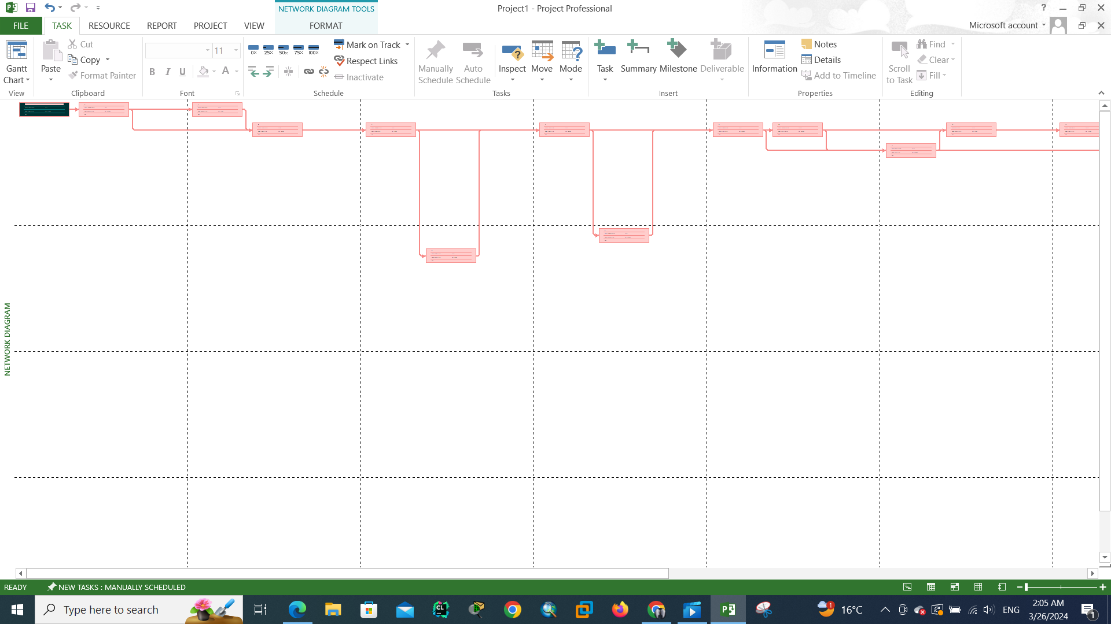
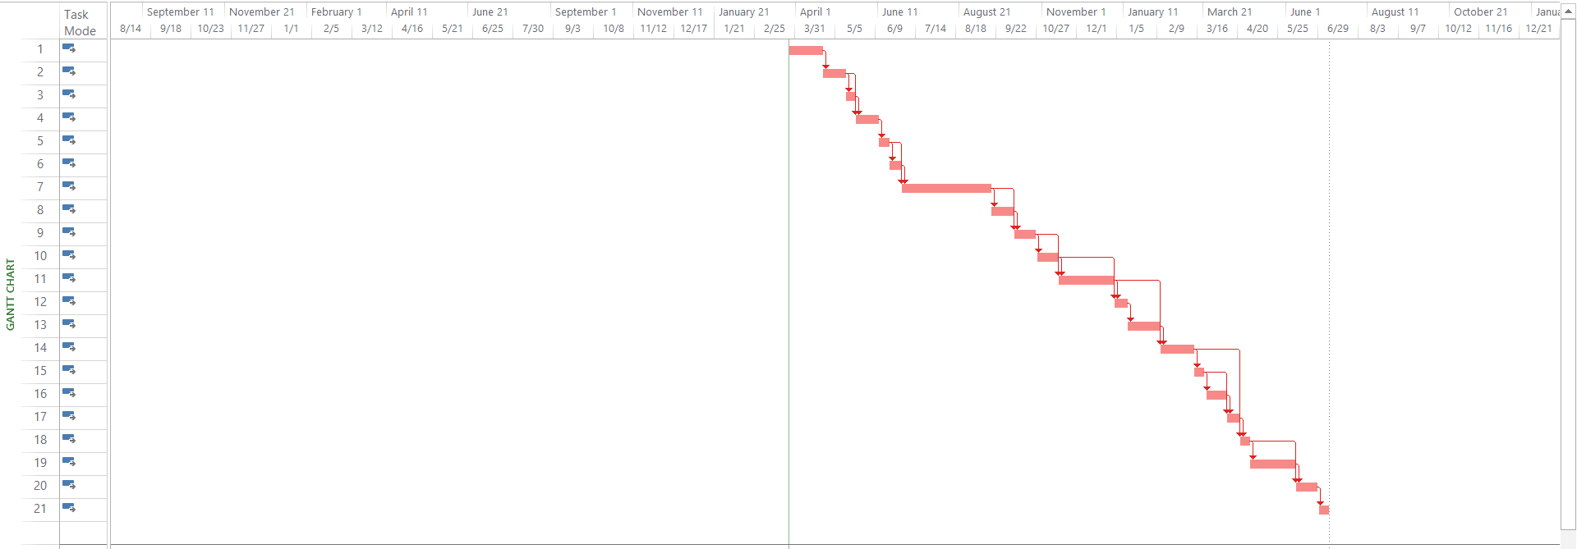

Risk Management
Risk | Probability | Impact | Mitigation Strategy | Responsible
Delay in requirements gathering | Medium | High | Conduct weekly meetings, finalize requirements early | Project Manager / UI/UX
Integration delays (frontend-backend) | Medium | High | Use Agile sprints, early API mockups, continuous integration | Backend & Frontend Developers
Database performance issues | Medium | Medium | Indexing, query optimization, load testing | Backend Developer
Security vulnerabilities | Low | High | Input validation, JWT authentication, password hashing, code reviews | Backend Developer
Unexpected bugs | Medium | Medium | Continuous testing, bug tracking, allocate buffer time | All team members
Deployment failures | Low | Medium | Use staging environment, automated deployment scripts, backup systems | Backend Developer / Frontend Lead
Scope creep | Medium | High | Strict change control, document scope clearly, approvals before new features | Project Manager
Low user adoption | Low | Medium | User-friendly UI, feedback sessions, tutorials | UI/UX + Frontend Developers
Data loss / backup failure | Low | High | Regular database backups, test restore procedures | Backend Developer

Role | Team Member | Responsibilities | Allocation
Project Manager | 4 Person | Planning, timeline tracking, coordination, risk management | 15–20%
UI/UX Designer | 1 Person | Wireframes, prototypes, design system, final UI | 25% (first 5 weeks)
Frontend Developer | 4 Person | Implement UI, pages, API integration, responsive design | 40%
Backend Developer | 1 Person | API development, database design, authentication, business logic | 40%
QA/Test Engineer | 1 Person | Testing, bug tracking, system validation, user testing | 20% (last 4 weeks)

Resource Allocation

KPI | Description | Target / Metric
System Uptime | Measures the availability of the platform | ≥ 99% uptime
API Response Time | Measures backend performance and speed | ≤ 300ms per request
User Registration Rate | Tracks number of new users signing up weekly | ≥ 50 new users/week (example)
Job Posting Activity | Measures number of jobs posted by companies | ≥ 10 new jobs/week
Successful Job Applications | Counts applications submitted successfully | ≥ 90% of submitted applications processed without errors
User Engagement | Tracks active users interacting with the platform | ≥ 60% of registered users active monthly
Bug Resolution Rate | Measures how quickly identified issues are resolved | ≥ 90% of critical bugs fixed within 1 week
Page Load Speed | Measures frontend performance | ≤ 2 seconds average load time
User Satisfaction | Collect feedback from users | ≥ 80% positive feedback from surveys
Security Compliance | Monitor authentication, encryption, and data protection | 0 major security breaches

Section 2 Requirements Gathering
2.1 Stakeholder Analysis
Stakeholder | Role | Needs / Expectations
Job Seekers | Users seeking jobs | Easy registration, profile creation, CV upload, job search, simple application process, notifications
Employers / Companies | Post jobs and manage applicants | Register company profile, post jobs, manage applications, review applicants, update job status
Admin (optional) | System monitoring | Monitor user activity, manage reported issues, ensure system uptime and security
Project Team | Developers & Designers | Clear requirements, user feedback, proper timelines, manageable scope

2.2 User Stories & Use Cases
User Story | Use Case / Scenario
As a job seeker, I want to register and create my profile | User fills registration form, uploads CV, completes profile details
As a job seeker, I want to search for jobs | User applies filters (job title, category, company) to browse available jobs
As a job seeker, I want to apply for jobs | User clicks “Apply”, submits application, receives confirmation
As a company, I want to register and create a company profile | Company enters info, uploads logo, sets up profile
As a company, I want to post jobs | Company adds job title, description, requirements, deadline
As a company, I want to manage applicants | Company views applicants, filters by status, updates application status
As a user, I want to receive notifications | Users get updates about application status and new jobs

3.3 Functional Requirements
- User registration & authentication (JWT)
- User profile creation & editing
- CV / image upload
- Job search & filtering
- Job application submission
- Company registration & profile management
- Job posting, editing, and deletion
- Application tracking and status updates
- Admin panel (optional)
- Notifications for users and companies
- Frontend-backend integration
- Responsive UI for mobile and desktop

3.4 Non-Functional Requirements
Requirement | Description / Criteria
Performance | API response time ≤ 300ms, Page load ≤ 2 seconds
Security | JWT authentication, hashed passwords, input validation, protection against attacks
Usability | Intuitive navigation, responsive design, clear feedback messages, accessible UI
Reliability | 99% uptime, error handling, database backups, fail-safe mechanisms
Scalability | System architecture supports future feature expansion and growing user base
Maintainability | Well-documented code, modular design, reusable components
Compatibility | Works on major browsers and devices (desktop & mobile (InProgress))

Section 3 System Analysis & Design

3.1 Project Objectives
General Objectives
- Develop an integrated recruitment platform that connects job seekers and companies efficiently.
- Provide an intuitive, modern user interface ensuring smooth navigation and usability.
- Reduce the time and effort required for both applying to jobs and managing applications.

Objectives for Job Seekers
- Allow users to register easily and complete their profiles through structured profile-building steps.
- Enable users to browse, search, and filter jobs based on skills, location, and experience.
- Provide the ability to apply for jobs directly and track application status.
- Support editing profile information and managing personal data.
- Allow users to log in, log out, and maintain secure authenticated sessions.

Objectives for Companies
- Provide a company registration and verification process.
- Allow companies to create and manage job posts with all required details.
- Enable companies to view candidates, check applications, and access applicant information.

3.2 Software Architecture
1. Modular MVC-style (Service-oriented single-repository / Monolith with modular services)
- Use an MVC-like separation for the backend (Controllers → Services → Models).
- Structure the codebase into clear modules (auth, users, companies, jobs, applications, notifications).

2. Major Components & Responsibilities
Frontend
- Technology: React
- Responsibilities: UI, routing, state management, form validation, file uploads, calling backend APIs, responsive behaviour, client-side caching.
- Artifacts: SPA bundles, static assets, design system (colors, typography), reusable components.
Backend (API Server)
- Technology: Node.js + Express
- Responsibilities: Authentication & authorization, business logic, routing, validation, file handling endpoints, error handling, exposing RESTful APIs
- Pattern: Controllers handle HTTP layer → Services implement business logic → Models (Mongoose) represent DB entities.
Database
- Technology: MongoDB (Mongoose ODM)
- Responsibilities: Persist users, companies, profiles, jobs, applications, notifications, and audit logs.
- Design: Collections: Users, Profiles , Companies, Jobs, Applications
File Storage
- Local (dev): filesystem (uploads/)
- Production: Cloud object storage (Cloudinary).
- Responsibilities: Store profile images

Authentication & Security
- JWT for stateless session tokens (access token + optional refresh token).
- Passwords hashed with bcrypt.
- Input validation with library (e.g., express-validator).

3. Components Interaction (High-level data flow)
- User opens frontend (React) → fetches static assets from CDN / frontend host (Vercel / Netlify / S3 + CloudFront).
- Frontend calls Backend REST API (HTTPS) for authentication, profile, job search, apply, etc.
- Backend validates request → calls service layer → reads/writes MongoDB.
- For file uploads: frontend uploads file to backend which streams to cloud storage (or uploads directly to signed S3 URL; backend stores metadata in DB).
- Backend enqueues background tasks for async operations (notifications, emails).
- Worker processes tasks and updates DB / sends external messages.
- Frontend polls or fetches notifications via API; could use WebSocket for real-time updates later.

4. Typical Request Sequence (example: Apply for Job)
- POST /auth/login/company-signup/user-signup → frontend receives JWT.
- GET /jobs → frontend lists jobs.
- User clicks job → GET /jobs/:id → view details.
- POST /jobs/:id/apply (Authorization header: Bearer <token>) → backend:
  - Validate user profile completeness.
  - Create Application document in DB.
  - Update job’s applications
- Jobseeker sees success message; company can GET /companies/:id/applicants.

5. Data Model (summary)
- User: _id, name, email, passwordHash, roles (jobseeker/company), profileId, createdAt
- Profile: _id, userId, experience, skills[], resumeUrl, photoUrl, location
- Company: _id, ownerUserId, name, logoUrl, description, createdAt
- Job: _id, companyId, title, description, requirements, location, deadline, createdAt
- Application: _id, jobId, userId, resumeUrl, status (pending/accepted/rejected), appliedAt

3.3 ER Diagram & Logical & Physical Schema

ERD Diagram

Logical Diagram

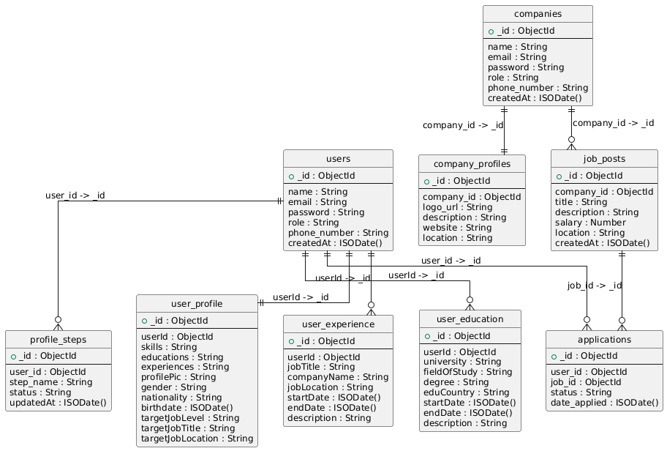

Physical Diagram

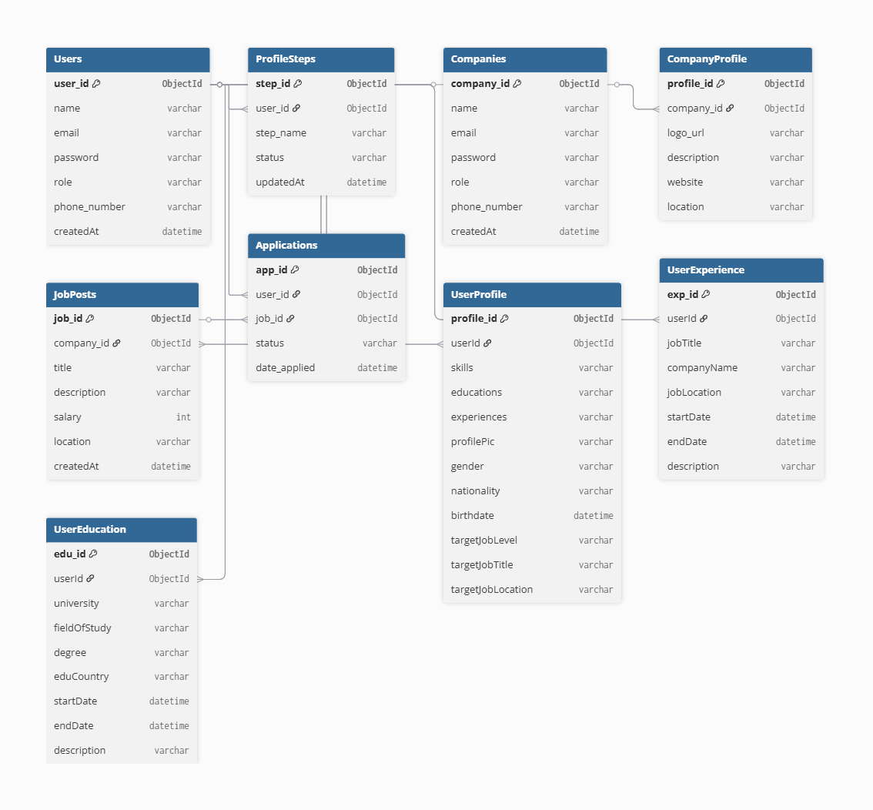

Use Case Diagram

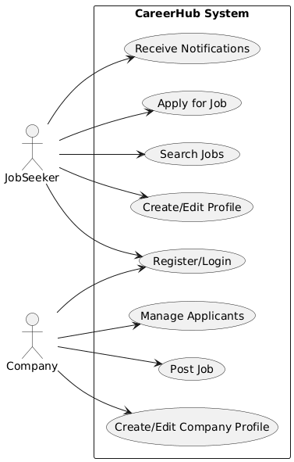

Activity Diagram

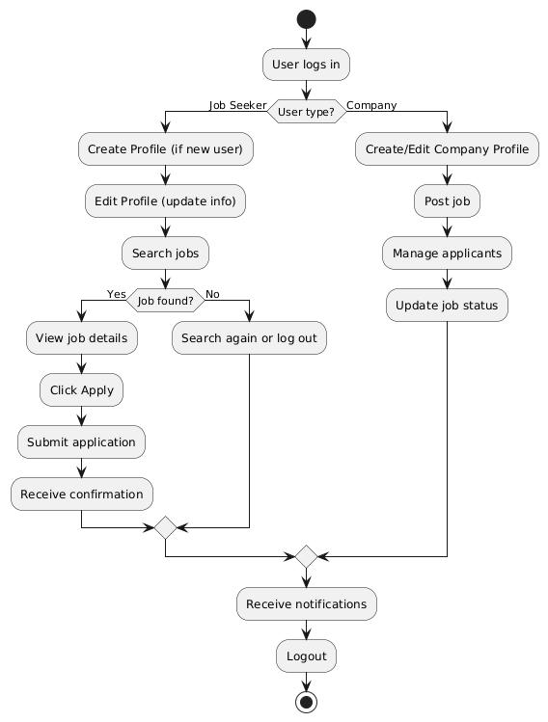

Class Diagram

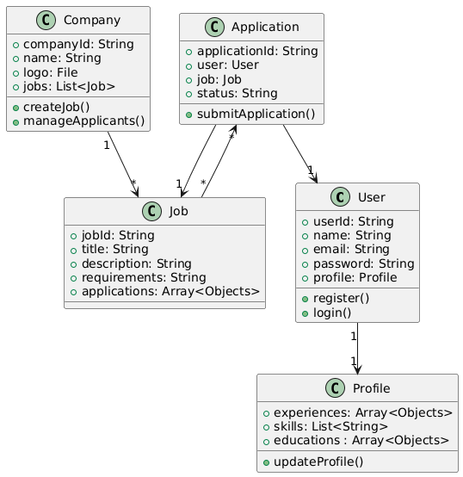

State Diagram

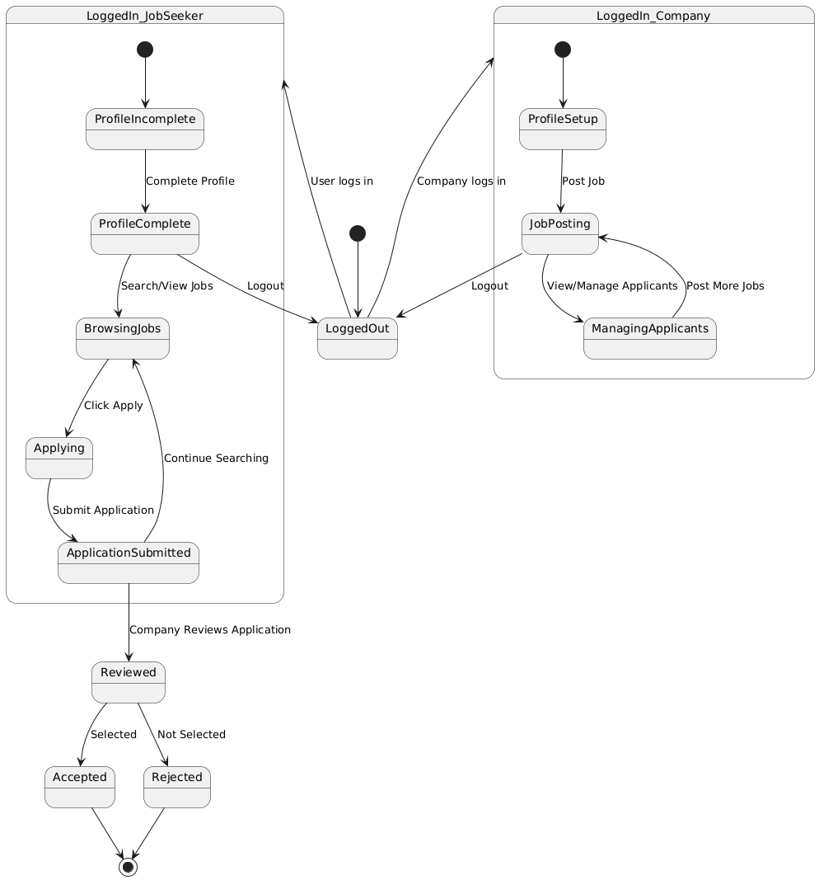
Sequence Diagram

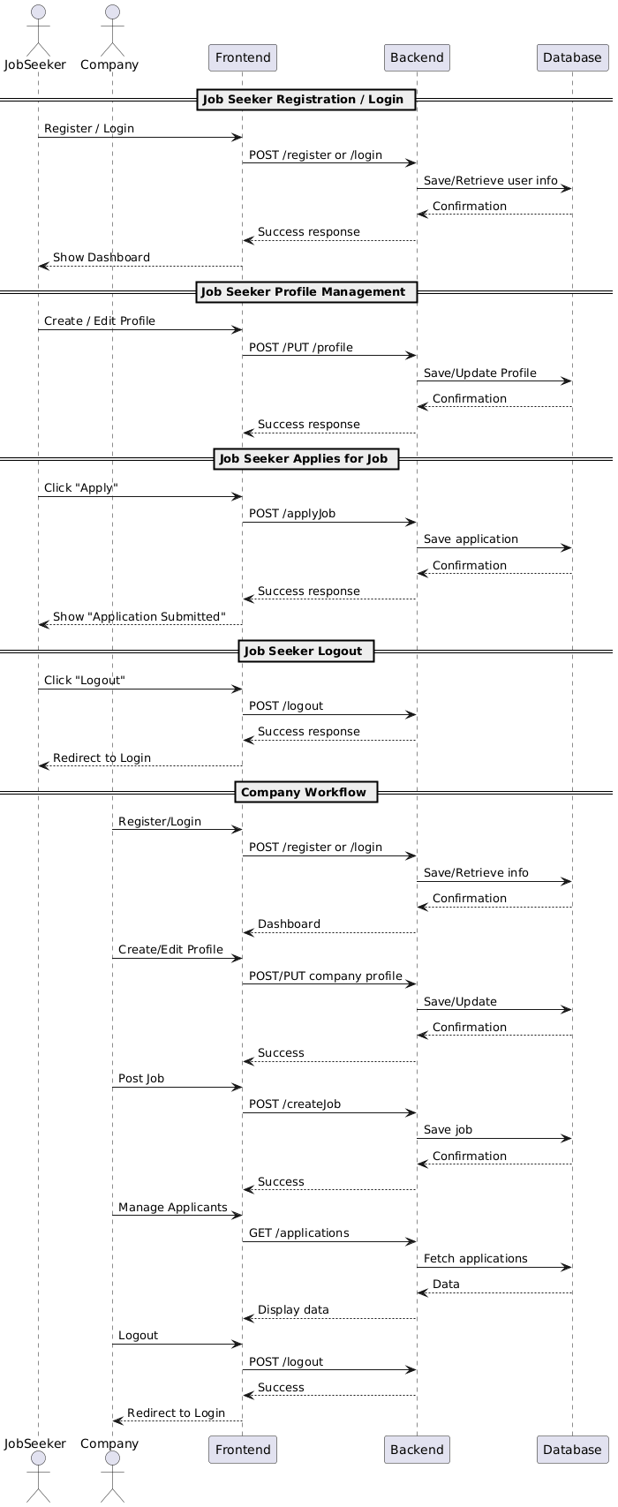

3.6.1 Technology Stack
Layer | Technology / Tool | Purpose
Frontend | React.js | Build interactive web UI
Backend | Node.js + Express.js | Handle API requests, server-side logic
Database | MongoDB | Store user, company, and job data
Authentication | JWT (JSON Web Tokens) | Secure login and session management
HTTP Client | Axios | Handle API calls from frontend
Styling / UI | Tailwind CSS / Material UI | Design responsive, modern UI
Version Control | Git / GitHub | Code collaboration and versioning
CI/CD | GitHub Actions (optional) | Automate build, test, deployment
API Testing | Postman | Test REST API endpoints

3.6.2 Deployment Diagram
Description:
The deployment diagram represents how the CareerHub system components are distributed across servers, clients, and the database.
Components & Deployment Nodes:
- Client Node (Web Browser / User Device)
  - Runs the React frontend
  - Sends HTTP requests to the backend API
- Web Server Node (Backend Server)
  - Runs Node.js + Express API
  - Handles business logic and authentication
  - Connects to the database

- Database Node
  - MongoDB database instance
  - Stores users, companies, jobs, applications, profiles, etc.
Deployment Relationships:
- Client → Web Server : Sends HTTP/HTTPS requests (REST API)
- Web Server → Database : Executes queries, CRUD operation

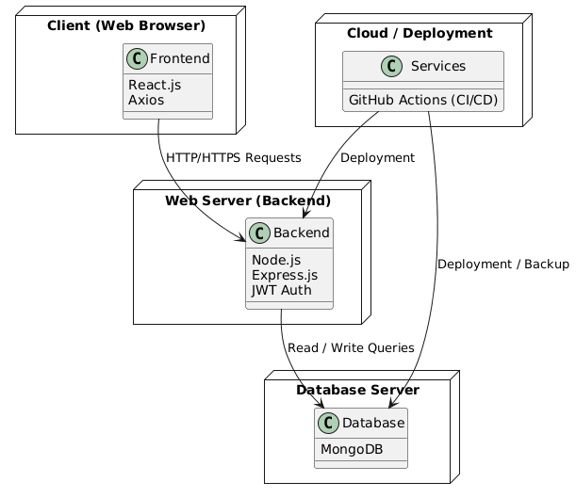
Deploy Diagram

3.6.3 Component Diagram
